Website Planning Document

Temple Inn & Suites Term Website Project

Veronica Jacobs

CIT 230

# Site Purpose

The purpose of the site is to promote and provide information about the specialized services that this hotel chain offers to meet the needs of temple patrons who come to serve in the temple or who participate in events such as sealings, weddings, receptions, and youth trips.

Client’s functional specifications: Landing page providing images of temples and temple attending activities, a call to action to make a hotel reservation, readily available navigation and contact information for the hotel chain, summary information about a temple.

A temple page describing four temples with the address, telephone, email, services, history, ordinance/session schedule, temple closure schedule, and summary—current weather information.

The reservation page contains a form that collects relevant information when making a normal stay reservation including the location, date, number and type of rooms, registrant's full name, email, phone, home state or country, and special accommodations/comments. You will need to use the CSS flex method for the layout of your reservation form for full credit.

The services page provides a list with information of the amenities and special services offered at the hotel along with the following sub pages/content:

The reception page displaying information about the wedding reception accommodations, including options for food service and setup.

A full-time temple missionary page that provides information and images about the suites offered at the hotel with a simple Contact Us form for more details.

The contact page will contain essential contact information including an embedded Google map (Links to an external site.)Links to an external site. showing the company headquarter address at 4800 Montgomery Ln #300, Bethesda, MD 20814 and a basic Contact Us form.

The industry: Clothing industry, weather industry

Goals: Provide information to users about what to wear in todays weather.

# Target Audience and Scenarios

## Audience

Who: Mostly women, people who are leaving their homes to run errands or go to work or school, fashionistas, mothers with young children, savvy dressing guys, anyone who wants to dress appropriately for the weather.

Age: 14 to 100

Income: $40,000 and above annually

Education: All levels. Students, college graduates, mostly bachelors-level

Experience with the topic: They have used other weather sites in the past.

Family status: All. Single, married, married with kids

Where will the user be accessing the site: From their homes

When will the user be accessing the site: In the morning, before they leave for work, school, or to run errands.

How will the user be accessing the site: Mostly from a mobile phone, a few from tablets, and even fewer from desktops.

User’s motivation for visiting the site: They want to know what clothes would be appropriate for the day’s weather.

Personas

### Sally Smith



Occupation: Stay-at-home mom

Demographics and Education: 28 years old, married, mother of 2, has some college education.

Goals and motivation for using the site: She is leaving the house with her children to go to the grocery store and wants to know what she and her children should wear.

Environment: She lives in a small house in the suburbs. Most of her friends are other young moms. She is comfortable using a smart phone. She uses social media extensively to keep in touch with family who lives far away and get parenting tips. She used to be pretty active, these days she chases a toddler around.

Quote: “Motherhood is the greatest thing and the hardest thing.”

### Ryan Dodd



Occupation: Senior Business Operations Program Manager at a big tech company

Demographics and Education: 35 years old, single, has a BA in Communications/Public Relations

Goals and motivation for using the site: He is a savvy dresser, likes fashion. He wants to know if the weather will be nice and if he can wear his new shoes today.

Environment: He lives alone in a nice apartment in a big city. He enjoys going out on the town with his other single friends. He is very comfortable with technology. He is a proud Apple user. His career is very important to him. He plays in a local soccer league on the weekends.

Quote: “Self-belief and hard work will always earn you success.”

Scenarios

What is the weather today?

How cold is its, will I need a jacket or a coat?

Will I need a jacket later tonight, after it gets dark?

Is it going to be wet, should I wear my rain boots?

Can I wear my new shoes or is it going to rain or snow?

I’m going to the park today, what should I wear?

What kind of clothes should I pack for my vacation?

I know I will be warm enough in this outfit, but will my baby?

Will I need an umbrella today?

Do I need to buy a running jacket for the race this weekend?

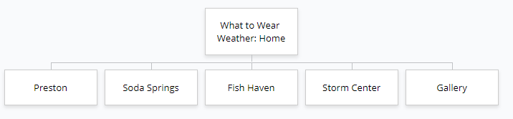Site Map

# Color Scheme

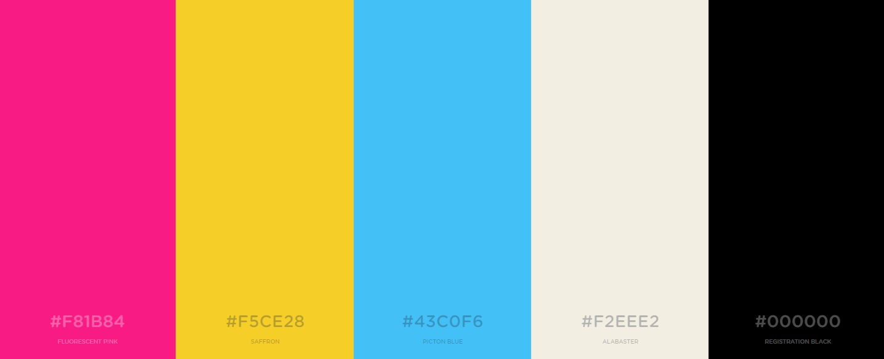

A picture containing screenshot

Description generated with very high confidenceThe background of my site will be Alabaster. The majority of the text will be Registration Black. Headings against colored backgrounds will be Alabaster. The header and the footer will be Picton Blue. The nav bar will be Saffron. The snap shot of current conditions and weather summary will have Fluorescent Pink background. The body of my site will alternate between Saffron and Fluorescent Pink. If the body copy is hard to read, I will make the background Alabaster and the frame Saffron or Fluorescent Pink.

###### Figure 1: Mockup of Site with Colors

# Typography

Headings: Vidaloka



I chose this font because it looks like a font that would be used for the title of a fashion magazine.

Body copy: Open Sans



I chose this font because it contrasts well with Vidaloka and it is easy to read.

Code to embed fonts into HTML:

<link href="https://fonts.googleapis.com/css?family=Open+Sans|Vidaloka" rel="stylesheet">

CSS rules to specify these families:

font-family: 'Vidaloka', serif;

font-family: 'Open Sans', sans-serif;

Sample:



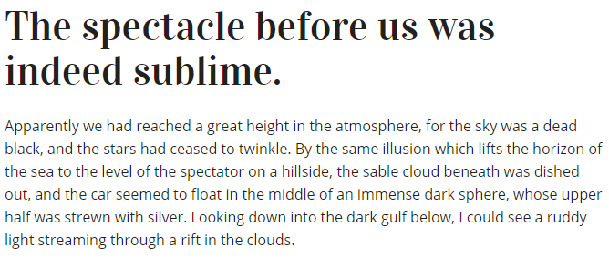

# Wireframe Sketches

A screenshot of a video game

Description generated with high confidence

A screenshot of a cell phone

Description generated with very high confidenceA screenshot of a computer

Description generated with very high confidence